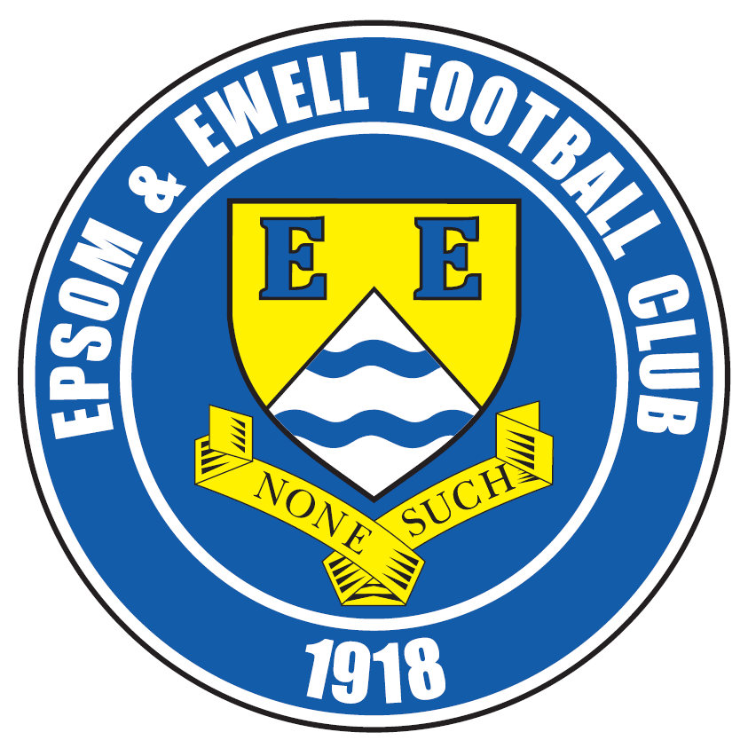 | Epsom & Ewell F.C.  12  v  AFC Hayes  Saturday, 26th November 2016 – 3.00 p.m.
Good afternoon! We host AFC Hayes today for a League match and welcome their players, officials and supporters and of course our own hardy regulars. We also welcome their Assistant Manager Alan Galloway who made 41 appearances for us during the 1996/97 season.

This is our opponents’ second season in this league having moved from the Southern League in 2015. Last year was a struggle for them and we drew here 1-1 in September but won at Farm Park in April by seven clear goals in what was clearly one of our better performances of the season.

This season looks like being another difficult one, although they were narrowly beaten by the all-conquering league leaders, Hartley Wintney on Saturday and fought back from two goals down to claim a 2-2 draw at CB Hounslow United in midweek. For our part we go into this match on a run of four straight league wins and need to keep that run going if we are to entertain any thoughts of catching the teams above us.

Last Saturday’s match was witnessed by very few in horrible conditions, but it was a very entertaining contest with Bedfont Sports in good form, taking the lead before Daryl Cooper-Smith equalised almost immediately after. In the second half we kept the intensity up and it was too much for them as we scored four goals in the final twenty minutes to secure a 5-1 win.

We were expecting a Saturday off next week after our Vase defeat to Abbey Rangers, but regrettably we have been given a League Cup Third Round tie at Worcester Park instead. I say, regrettably, as we will have four players out with suspension for this important match. Still, we have a good squad at present and I still think we can progress to a Quarter-Final at either Sutton Common Rovers or Walton & Hersham. Please note that we have an early kick off at 1.30pm as they have no floodlights at Green Lane.

Following that match we “host” our landlords Chipstead in the Surrey Senior Cup on Tuesday 6th December; a match that is also doubling as the tenth Dave Wilson Trophy. We will have all of our suspended players, except Reisse Griffin available again for this match so Glyn will get the opportunity for a bit of squad rotation over the next few days. We then face a big test as we visit Hartley Wintney on Saturday 10th December in a League match.

We are still in urgent need of both match and player sponsors, so if you can help, or know someone at a local business who might be interested, please have a word with a Committee Member for details. Thank you!

Enjoy the game!

Rich

You can follow us on Facebook: www.facebook.com/epsomandewellfc Twitter: @EEFCOfficial and
Instagram at: www.instagram.com/epsomandewellfc We also have a Youtube channel now!

Cover photos by Gemma Jarman

- Jordan Gallagher scores our fourth goal against Bedfont Sports on Saturday

- Alex McKay scores our fifth goal in the same match


Cherry Red Records Combined Counties League
Premier Division Table 2016/17
incl Wednesday 23rd November | P | W | D | L | F | A | Pts | GD | H | A
Hartley Wintney | 20 | 17 | 2 | 1 | 73 | 21 | 53 | +52 | 18/3 | 10/12
Westfield | 19 | 12 | 5 | 2 | 42 | 18 | 41 | +24 | 18/2 | 1-2
Hanworth Villa | 20 | 12 | 3 | 5 | 36 | 25 | 39 | +11 | 13/12 | 14/1
Knaphill | 20 | 11 | 2 | 7 | 44 | 35 | 35 | +9 | 4-0 | 8/4
Guildford City | 22 | 10 | 4 | 8 | 50 | 46 | 34 | +4 | 17/1 | 2-0
Epsom & Ewell | 18 | 10 | 3 | 5 | 46 | 25 | 33 | +21 | X | X
Horley Town | 17 | 10 | 3 | 4 | 39 | 24 | 33 | +15 | 3-0 | 17/4
Walton & Hersham | 16 | 9 | 5 | 2 | 27 | 14 | 32 | +13 | 4/3 | 1-1
Colliers Wood United | 20 | 8 | 5 | 7 | 38 | 34 | 29 | +4 | 14/4 | 0-5
Bedfont Sports | 17 | 9 | 2 | 6 | 35 | 35 | 29 | 0 | 5-1 | 7/2
Camberley Town | 18 | 8 | 3 | 7 | 35 | 21 | 27 | +14 | 0-0 | 1/4
Windsor | 21 | 7 | 5 | 9 | 35 | 40 | 26 | -5 | 2-0 | 1-2
CB Hounslow United | 17 | 8 | 2 | 7 | 32 | 32 | 26 | 0 | 1-5 | 12/11
North Greenford United | 18 | 6 | 4 | 8 | 36 | 38 | 22 | -2 | 22/4 | 1-2
Abbey Rangers | 19 | 6 | 4 | 9 | 28 | 37 | 22 | -9 | 7-1 | ???
Spelthorne Sports | 18 | 5 | 5 | 8 | 29 | 32 | 20 | -3 | 7/1 | 25/2
Farnham Town | 17 | 6 | 1 | 10 | 28 | 39 | 19 | -11 | 25/3 | 2-1
AFC Hayes | 19 | 5 | 3 | 11 | 27 | 38 | 18 | -11 | 26/11 | 28/1
Raynes Park Vale | 21 | 4 | 5 | 12 | 27 | 44 | 17 | -17 | 27/12 | 1-1
Sutton Common Rovers | 17 | 4 | 3 | 10 | 20 | 33 | 15 | -12 | 2-1 | 2/1
Chertsey Town | 18 | 4 | 3 | 11 | 19 | 48 | 15 | -29 | 17/12 | 11/2
Badshot Lea | 20 | 4 | 1 | 15 | 26 | 59 | 13 | -33 | 4/2 | 4-1
Bedfont & Feltham | 20 | 3 | 3 | 14 | 24 | 58 | 12 | -34 | 21/1 | 9-2

Lucky Day? – 26th November
Played 16 - W 8 D 2 L 6 - For 50 Against 42 - PPG 1.63 - Above Average
Our Club record against AFC Hayes (incl Brook House)
Played 8 - Won 2 Drawn 2 Lost 4 - F 16 A 15 - PPG 1.00 - Poor
Our Largest wins and losses against our opponent
12th April 2016 - W 7-0 - Combined Counties League (A)
29th January 2005 - L 0-3 – Isthmian League Division Two (H)
Their Last Visit
Saturday 19th September 2016 - D 1-1 - Combined Counties League

Club Manager – Glyn Mandeville
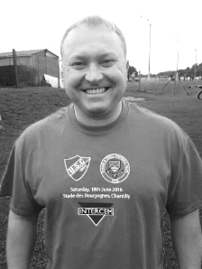
Hello and welcome to all from A.F.C. Hayes. I hope you enjoy the game and I wish you all a safe trip home.

We go into this match on the back of four straight wins in the League, which have placed us much nearer to where I expect us to be. There is still much work to do but if we can win today we then have two cup matches to come before taking on the league leaders Hartley Wintney and it would be great to take this winning run into that match.

We played well on Saturday and by the end Bedfont Sports were not able to match our intensity. I hope that continues today. Right now there is massive competition for places which is important. A deep squad is vital, especially with the upcoming suspensions, most of which will hit us at Worcester Park next Saturday.

Thanks to everyone for their continued support. I know the players appreciate it.

Manders

Epsom & Ewell F.C. Colts

Today we welcome some of the players from Epsom & Ewell Colts F.C. and their parents. It is always good to see them at our matches, as they represent the supporters of the future.

The Colts do an excellent job in the Borough and provide playing opportunities for over 350 children who make up twenty-five boys teams and seven girls teams, all aged between 5 and 18.

We hope you enjoy your visit and hope to see you all here again soon.

James Taylor
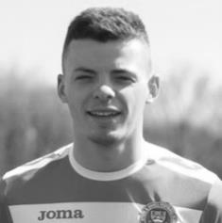
On the 23rd April 2017 I will be stepping out of my comfort zone, running the London Marathon for the very first time. Running alongside me will be my OLD man, David, a former Salt himself.

We will be raising money for an amazing charity called PSP (Progressive Supranuclear Palsy). Sadly my girlfriend lost her grandad to this rare and devastating disease in September 2016.

If you would like to support me, any donations (however little), would be greatly appreciated. Thank you!

http://uk.virginmoneygiving.com/James-Taylor

James

Alex McKay

For the sixth year in a row Alex is growing a moustache for Movember and is looking for your help.

He is raising money for awareness of Prostate Cancer and would be grateful for your donations.

If you would like to support him, please send any donations to:

http://mobro.co/mckay2016

Latest Results and Fixtures
Combined Counties League Cup Second Round – Saturday 19th November
Worcester Park | 8-1 | Cove
Combined Counties League – Saturday 19th November
AFC Hayes | 2-3 | Hartley Wintney
Bedfont & Feltham | 1-4 | Walton & Hersham
Camberley Town | 1-1 | Raynes Park Vale
Chertsey Town | 1-3 | Windsor
Colliers Wood United | 2-1 | Badshot Lea
Epsom & Ewell | 5-1 | Bedfont Sports
Guildford City | 3-0 | CB Hounslow United
North Greenford United | 1-3 | Knaphill
Spelthorne Sports | 0-3 | Horley Town
Sutton Common Rovers | 2-3 | Farnham Town
Westfield | 2-2 | Abbey Rangers
Combined Counties League Cup Second Round – Monday 21st November
Sutton Common Rovers | 2-1 | Bedfont Sports
Combined Counties League Cup Third Round – Tuesday 22nd November
Farnham Town | 0-4 | Camberley Town
Surrey Senior Cup Second Round – Tuesday 22nd November
Walton & Hersham | 3-0 | Croydon
Combined Counties League – Tuesday 22nd November
Badshot Lea | 3-2 | Spelthorne Sports
CB Hounslow United | 2-2 | AFC Hayes
Westfield | p-p | Horley Town
Combined Counties League – Wednesday 23rd November
Guildford City | 0-4 | Colliers Wood United
Combined Counties League – Saturday 26th November
CB Hounslow United | V | Westfield
Chertsey Town | V | Bedfont Sports
Epsom & Ewell | V | AFC Hayes
Farnham Town | V | Badshot Lea
Hanworth Villa | V | Spelthorne Sports
Hartley Wintney | V | Guildford City
Horley Town | V | Camberley Town
Knaphill | V | Sutton Common Rovers
Latest Results and Fixtures
Combined Counties League – Saturday 26th November
Raynes Park Vale | V | Abbey Rangers
Walton & Hersham | V | North Greenford United
Windsor | V | Colliers Wood United
Surrey Senior Cup Second Round – Monday 28th November
Sutton Common Rovers | V | Camberley Town
Surrey Senior Cup Second Round – Tuesday 29th November
Badshot Lea | V | Farnham Town
Chertsey Town | V | Abbey Rangers
Combined Counties League – Tuesday 29th November
Hartley Wintney | V | Hanworth Villa
Windsor | V | Spelthorne Sports
Surrey Senior Cup Second Round – Wednesday 30th November
Guildford City | V | Horley Town
Buildbase F.A. Vase Third Round – Saturday 3rd December
Abbey Rangers | V | Eastbourne Town
Crowborough Athletic | V | Bedfont Sports
Knaphill | V | Southall
Combined Counties League Cup Third Round – Saturday 3rd December
Worcester Park | 1.30 pm | Epsom & Ewell
Combined Counties League – Saturday 3rd December
Badshot Lea | V | AFC Hayes
Bedfont & Feltham | V | Guildford City
Camberley Town | V | Windsor
Colliers Wood United | V | Spelthorne Sports
Farnham Town | V | Chertsey Town
Horley Town | V | Westfield
North Greenford United | V | Raynes Park Vale
Walton & Hersham | V | Hartley Wintney
Buildbase F.A. Vase Third Round – Sunday 4th December
Sutton Common Rovers | V | Corinthian
Surrey Senior Cup Second Round – Tuesday 6th December
Epsom & Ewell | V | Chipstead

From behind the goal
Epsom & Ewell 5-1 Bedfont Sports
Combined Counties League - Premier Division - Saturday 19th November 2016

Super Salts are too good for Sports in the end

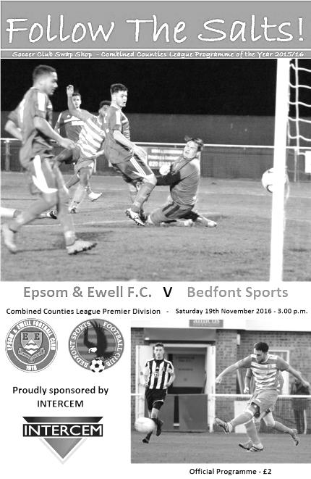
The conditions at High Road were wet and cold, but anyone who ventured out to watch was rewarded with one of our best displays of the season as high-flying Bedfont Sports were simply taken apart in the end by some excellent football, particularly in the second half.

There was maybe unsurprisingly just one change to the starting eleven following the win over Windsor on Tuesday as Michael Eacott returned in goal for Ali Turpie and it has to be said he made some key saves in the first half, without which we may not have been able to launch our second half onslaught.

We started off positively with a Matt Tanton cross being inches too high for Daryl Cooper-Smith who was again unfortunate moments later when he controlled a low ball in, turned his defender but then slipped himself, giving their man time to recover and block the shot for a corner. We had a little scare when a high ball was sent in but Eacott couldn't reach it and it fell for a Bedfont striker but his volley was wide of the goal. A Matt Ferdinando free kick was hit low and hard but was just wide of the far post.

All this and the match was only 10 minutes old! Both teams continued to attack but we looked slightly more threatening at this point and the visitors custodian Terry Buss, who had played so well against us on various occasions for Hanworth Villa, was definitely the busier of the two keepers. Despite this, we conceded in the 29th minute. Ferdinando tried a crossfield ball but it was intercepted and from the break, the ball was fed down the left hand side where Scott Harris was able to beat Eacott from close range.

This was harsh based on the play to that point but we were level inside a minute. A ball through to Jordan Gallagher was chested back for Cooper-Smith and he rode the challenge on the edge of the area before driving past two other defenders and smashing the ball via the keeper's fingertips just inside his right hand post.

Following the equaliser the visitors then had their best spell of the match. Eacott stood up to deny a striker as he raced on to a long ball in the 38th minute and within a minute he was there again to block a powerful shot from just inside the area. However, an even better save came just before the interval when a shot from the edge of the area deflected off one of our

players and looped up, but big Mike managed to turn and back pedal in one movement to tip the ball over the bar.

Overall it was a fair score line at the half. The visitors had started to show the form that had put them in the Third Round of the Vase as the half had closed and we needed to grab the momentum back. The second half started with chances for both sides as a close range effort for the visitors was blocked over the bar for a corner but from the set piece Agi Panayiotou made a storming run forwards only to see his shot blocked on the edge of the area at the last minute. The play then spread to the other end from where the striker had a clear shot on goal but he pulled the effort wide.

From this point we took control. A Gallagher run was ended crudely on the edge of the area by Rafiq Bettamer who became the second visitor in the book but Cooper-Smith clipped the free kick just wide. Then James Taylor got forward on the right. His cross was headed down by Cooper-Smith to Jason Nwachukwu but he was unable to keep his shot on target. The pressure continued and Nwachukwu and Matt Farrell set up Gallagher but from a really good position his shot was straight at Buss from eight yards and was kept out. Minutes later Cooper-Smith had his shot blocked by another desperate challenge and a dangerous Ferdinando cross was headed clear for a corner.

All this pressure had to count for something as from the Ferdinando corner to the far post Craig Hastings headed the ball back to Taylor who controlled the ball before steering it into the corner from inside the six yard box in the 67th minute. The hard work continue as it was clear we were not going to sit back on this lead and Nwachukwu had a chance as he collected a weak goal kick but was unable to beat Buss from the edge of the box and Cooper-Smith was denied by a superb last ditch challenge as it looked like he would be clean through. Reisse Griffin came on for Ferdinando and we got better still. Nwachukwu fed Farrell who twisted and turned on the edge of the area before unleashing a low left footed strike that Buss did really well to save but moments later the ball was in the net anyway as Griffin found space on the right and his low ball in was finished off into the roof of the net by the unmarked Cooper-Smith from six yards in the 82nd minute.

We made two further substitutions as Alex McKay and Rob Hendry joined the battle and Hendry held off a defender well with his first action to set up Griffin who put in another low ball which this time was met at the far post by Gallagher to make it 4-1 from close range in the 88th minute. Then in the first minute of injury time a Gallagher corner was headed back by Hastings to McKay. His first shot was blocked but the ball fell to him and he smashed it into the roof of the net from about ten yards to give us a 5-1 lead.

And that's how it finished. After an extremely even and competitive first hour we found another gear and it was just too much for the visitors who were blown away in the last half an hour. We appear to be finishing a lot of our matches stronger than the opposition which is another good sign as we registered our fourth straight league win which keeps us in sixth place but only eight points behind second placed Westfield with a game in hand.

Epsom and Ewell: Michael Eacott, James Taylor, Matt Tanton, Craig Hastings,
Dan Dean ©, Savvas 'Agi' Panayiotou, Matt Farrell, Daryl Cooper-Smith,
Jason Nwachukwu, Matt Ferdinando
Subs: Reisse Griffin for Ferdinando (75), Alex McKay for Farrell (85)
Rob Hendry for Cooper-Smith (87)

AFC Hayes – History

AFC Hayes changed the name of their senior teams from Brook House Football Club at the end of season 2006/2007. The club had been formed in 1974, springing from local Saturday sides Charville and Hayes North.

Success soon followed in the lower divisions of the Hayes and District Sunday League culminating in winning the Middlesex Sunday Junior Cup. Success continued with two League and Cup winning doubles before a switch to Saturday football in 1982 joining the now defunct South West Middlesex League.

Brook House then became founder members of The Middlesex County League before they joined the London Spartan League in 1989 when they were awarded senior status. In their first season, despite not finishing in one of the two promotion spots they were promoted to the Premier Division.

In 1992 the club had their floodlights erected and to mark the occasion, Chelsea were the first opponents under lights at Farm Park. In the same season, the final of the Spartan League Cup was reached, but Cheshunt took the trophy.

With the advent of their lights, the club was able to enter the F.A. Cup, and on two occasions they have reached the first qualifying round, most notably in 1995/1996 when they held Conference side Stevenage Borough to a 0-0 draw away only to lose the replay at home.

In 1997 Brook House appointed Mickey Harvey as manager with the express purpose of linking the Youth and Senior set ups. The move proved very successful as in its first season the club were Spartan South Midlands Premier Division (South) champions.

In 1999/2000 the club were runners up in the Premier Division of The Spartan South Midlands League and were Premier Division Cup winners. At the end of the 2001/2002 season, Manager Mickey Harvey decided to try pastures new, with Bob Strutton taking over.

2003/004 saw all the hard work and belief in younger players pay off, and we were never out of the top three in the league, eventually achieving second place. The lads also won the Challenge Trophy and were runners - up in the Premier Cup. Having just missed out promotion to the new National Step 4, we were invited into the Ryman Isthmian League Division 2.

In the close season, Bob decided to call it a day, so the Club again promoted from within. Joe Mitchell as manager with Colin Murphy as assistant and head coach.

2004/05 was a very good year - 3rd in the league behind Ware and Witham Town and last 16 of the FA Vase. In 2005/6 we won the last ever Isthmian League Associate Members Trophy beating Hertford 3 - 1 in the final. That placing and the E Level ground -grading saw us promoted to the newly -formed Step 4 Level and into The Southern League South & West Division.

After a promising start to the season we had a very indifferent second half, but we managed to achieve our main ambition of staying at this level. The highlight was coming runners-up in the Middlesex Senior Charity Cup.

From 2007-2008 the club started with the new name for our senior sides AFC HAYES. The Youth section are still carrying on our historic club name.

The 2008-2009 Season was the most successful season to date and the team finished 7th in the Southern League. This was overshadowed by winning the Middlesex Senior Cup for the very first time in the club's history. A 2-0 win over Hendon brought the trophy back to Farm Park.

During the next few seasons AFC Hayes consolidated in the Southern League and challenged for the Division One Central play-offs in 2011/12.

In 2012-13 we appointed Ian Crane who rebuilt the team. He was joined by Graham Goode as Assistant but in early December 2014 Graham left us followed by Ian’s resignation after xmas 2014. We appointed Paul Palmer and his assistant Colin Brown quickly, hoping to turn it around but were unable to escape relegation. After an indifferent start to the season with some good and bad results we agreed to part company in November 2015 and Sean Berry a well known local x player took on the role as Manager.

First Eleven Appearances 2016/17 - (max 24)
Name | Debut | 2016/17 |  |  |  | Career Totals
Name | Debut | App | Sub | Total | Goals | App | Sub | Total | Goals
CLARK-GLEAVE Charlie | 23/08/2016 | 1 | 2 | 3 | 0 | 1 | 2 | 3 | 0
COOPER-SMITH Daryl | 03/01/2015 | 18 | 1 | 19 | 19 | 48 | 9 | 57 | 39
DEAN Dan | 02/08/2014 | 16 | 2 | 18 | 0 | 84 | 6 | 90 | 2
EACOTT Michael | 02/08/2014 | 19 | 0 | 19 | 0 | 104 | 1 | 105 | 0
FARRELL Matt | 02/08/2014 | 23 | 0 | 23 | 11 | 109 | 4 | 113 | 29
FERDINANDO Matt | 20/09/2014 | 12 | 3 | 15 | 2 | 65 | 9 | 74 | 16
GALLAGHER Jordan | 07/08/2016 | 10 | 12 | 22 | 6 | 10 | 12 | 22 | 6
GRIFFIN Reisse | 08/08/2015 | 20 | 3 | 23 | 2 | 48 | 9 | 57 | 4
HASTINGS Craig | 08/08/2015 | 16 | 5 | 21 | 1 | 53 | 9 | 62 | 1
HEAGNEY Adam | 16/08/2016 | 13 | 3 | 16 | 0 | 13 | 3 | 16 | 0
HENDRY Rob | 08/08/2015 | 15 | 6 | 21 | 3 | 45 | 17 | 62 | 15
MCKAY Alex | 20/12/2008 | 14 | 3 | 17 | 3 | 122 | 33 | 155 | 11
NEALE Tom* | 13/10/2015 | 6 | 5 | 11 | 7 | 22 | 24 | 46 | 17
NORTH Rhys* | 16/08/2015 | 2 | 2 | 4 | 0 | 19 | 9 | 28 | 1
NWACHUKWU Jason | 01/10/2016 | 4 | 5 | 9 | 0 | 4 | 5 | 9 | 0
PANAYIOTOU Savvas | 03/01/2015 | 18 | 3 | 21 | 0 | 50 | 11 | 61 | 7
PRICE Matt* | 23/08/2016 | 2 | 0 | 2 | 1 | 2 | 0 | 2 | 1
ROBINSON Sam* | 22/10/2011 | 7 | 1 | 8 | 1 | 61 | 6 | 67 | 14
ROSE Daniel | 25/10/2016 | 1 | 1 | 2 | 0 | 1 | 1 | 2 | 0
SALEH Mennar* | 24/09/2016 | 0 | 2 | 2 | 0 | 0 | 2 | 2 | 0
SMITH Matt | 08/08/2009 | 0 | 1 | 1 | 1 | 91 | 44 | 135 | 11
TANTON Matt | 02/08/2014 | 20 | 1 | 21 | 1 | 77 | 5 | 82 | 3
TAYLOR James | 26/08/2013 | 18 | 3 | 21 | 1 | 104 | 15 | 119 | 7
THOMPSON Elliott | 09/02/2016 | 3 | 0 | 3 | 1 | 7 | 9 | 16 | 1
TURPIE Alistair | 31/03/2016 | 5 | 1 | 6 | 0 | 7 | 1 | 8 | 0
WATRET Jack* | 02/08/2016 | 1 | 0 | 1 | 0 | 1 | 0 | 1 | 0
* player has left the club

Combined Counties League Premier Division Opponents
All-time Records
incl Saturday 19th November | P | W | D | L | F | A | PPG | GD | Best  Win | Worst  Loss
Bedfont & Feltham | 1 | 1 | 0 | 0 | 9 | 2 | 3.00 | +7 | 9-2 | X
Spelthorne Sports* | 5 | 4 | 1 | 0 | 15 | 6 | 2.60 | +9 | 6-2 | X
Sutton Common Rovers | 11 | 9 | 1 | 1 | 29 | 13 | 2.55 | +16 | 4-0 | 1-4
Horley Town | 29 | 20 | 5 | 4 | 65 | 30 | 2.24 | +35 | 6-0 | 1-3
Colliers Wood United | 22 | 14 | 2 | 6 | 45 | 33 | 2.00 | +12 | 4-0 | 0-5
Bedfont Sports | 10 | 6 | 2 | 2 | 18 | 11 | 2.00 | +3 | 5-1 | 0-4
Abbey Rangers | 3 | 2 | 0 | 1 | 10 | 4 | 2.00 | +7 | 7-1 | 2-3
Westfield | 19 | 11 | 3 | 5 | 40 | 31 | 1.89 | +9 | 6-1 | 0-4
Farnham Town | 14 | 8 | 2 | 4 | 25 | 23 | 1.86 | +2 | 3-1 | 1-4
Knaphill | 7 | 4 | 1 | 2 | 15 | 8 | 1.86 | +3 | 4-0 | 1-2
Guildford City | 17 | 10 | 1 | 6 | 34 | 22 | 1.82 | +12 | 5-1 | 1-5
Hanworth Villa | 15 | 8 | 3 | 4 | 38 | 26 | 1.80 | +12 | 5-0 | 1-4
Raynes Park Vale | 27 | 13 | 6 | 8 | 58 | 37 | 1.67 | +21 | 6-1 | 0-2
Badshot Lea | 18 | 8 | 3 | 7 | 35 | 34 | 1.67 | +1 | 4-1 | 0-4
Walton & Hersham | 50 | 24 | 10 | 16 | 101 | 97 | 1.64 | +4 | 6-0 | 0-8
Camberley Town* | 89 | 38 | 22 | 28 | 158 | 123 | 1.52 | +35 | 9-1 | 0-4
Hartley Wintney | 10 | 4 | 3 | 3 | 25 | 17 | 1.50 | +8 | 5-0 | 2-4
Windsor | 49 | 19 | 12 | 18 | 90 | 90 | 1.41 | -2 | 4-0 | 0-6
Chertsey Town | 47 | 17 | 5 | 25 | 70 | 86 | 1.19 | -16 | 3-0 | 0-7
AFC Hayes | 8 | 2 | 2 | 4 | 16 | 15 | 1.00 | +1 | 7-0 | 0-3
North Greenford United | 11 | 3 | 2 | 6 | 15 | 20 | 1.00 | -5 | 3-0 | 1-4
CB Hounslow United | 2 | 0 | 0 | 2 | 2 | 7 | 0.00 | -5 | X | 1-5
* includes one abandoned match v Camberley and one loss on penalties v Spelthorne

EL Records Premier Challenge Cup
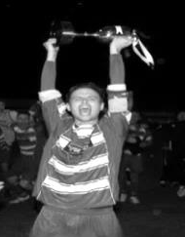
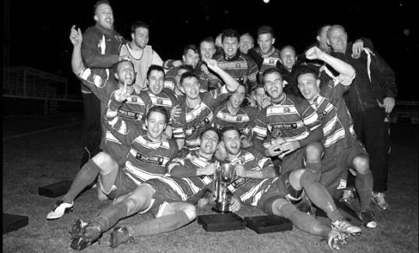
Second Round
Hanworth Villa | 2-4+ | Epsom and Ewell
AFC Hayes | 3-4 | Balham
Epsom Athletic | 1-5 | Windsor
Sutton Common Rovers | 2-1 | Bedfont Sports
Raynes Park Vale | 2-0 | Colliers Wood United
Frimley Green | 1-2 | Banstead Athletic
Westfield | 8-4+ | Redhill
Staines Lammas | 0-1 | Farnham Town
Worcester Park | 8-1 | Cove
Badshot Lea | 0-5 | Guildford City
Chertsey Town | 1-2 | Camberley Town
Cobham | 1-3 | Chessington & Hook United
Hartley Wintney | 4-0 | AC London
Horley Town | 2-2+ 5-4p | Sheerwater
Walton & Hersham | 5-1 | Eversley & California
Ash United | 2-0 | Farleigh Rovers
Third Round
Banstead Athletic | 4-4+ 3-4p | Westfield
Sutton Common Rovers | V | Walton & Hersham
Farnham Town | 0-4 | Camberley Town
Ash United | 0-2 | Windsor
Raynes Park Vale | 2-1 | Hartley Wintney
Guildford City | 2-1 | Balham
Horley Town | 2-0 | Chessington & Hook United
Worcester Park | 3/12 | Epsom & Ewell
Quarter Finals
Windsor | V | Horley Town
Guildford City | V | Raynes Park Vale
Westfield | V | Camberley Town
Sutton Common Rovers /  Walton & Hersham | V | Worcester Park /  Epsom & Ewell

Club Records - 26th November
Date | Day | Competition |  | Opponents |  | Scorers
26/11/27 | Sat | Surrey Senior Cup 3q | H | Aquarius | 7-3 | R.Marlow (3), J.Parr (2), F.Watts, F.Behn
26/11/32 | Sat | London League | H | Hendon | 5-5 | B.Williams (3), R.Marlow (2)
26/11/38 | Sat | London League | A | Royal Naval Depot (Chatham) | 4-1 | R.Forbes, A.Curtis, B.Solly, J.Jones
26/11/49 | Sat | Corinthian League | A | Edgware Town | 3-6 | F.Marshall, R.Orford, T.Wright
26/11/55 | Sat | Amateur Cup 4q | A | Redhill | 1-2 | D.Hermitage
26/11/60 | Sat | Corinthian League | H | Slough Town | 5-4 | T.Flynn (2), M.Simmons (pen), D.Mollatt, D.Mead
26/11/66 | Sat | Athenian Div 2 Cup 1 replay | H | Rainham Town | 1-4 | T.Williams
26/11/77 | Sat | F.A. Vase 2 | H | East Ham United | 3-0 | G.Butler, R.Parkin, T.Tuite
26/11/83 | Sat | Isthmian League 1 | A | Lewes | 3-2 | S.Hill (2, 1 pen), o.g.
26/11/85 | Tue | Isthmian League Cup 2 | H | Bishop's Stortford | 3-1 | D.Jones (2), T.Tuite
26/11/88 | Sat | F.A. Vase 2 | H | Three Bridges | 6-2+ | N.Robson (2), P.Andrews, B.Perkins, C.Walcott, C.Holding
26/11/94 | Sat | Isthmian League 3 | A | East Thurrock United | 4-1 | P.Meredith, T.Hoy (pen), T.O'Connor, S.Smith
26/11/02 | Tue | Isthmian League 1s | H | Dulwich Hamlet | 3-3 | J.Hall, K.Webb, S.Huckle
26/11/05 | Sat | Isthmian League 2 | A | Wembley | 2-4 | N.Williams, L.Gay
26/11/11 | Sat | Combined Counties  Premier Division | A | Windsor | 0-1
26/11/13 | Tue | Surrey Senior Cup 2 | A | Chipstead | 0-3
Historical Decades
Date | Day | Competition |  | Opponents |  | Scorers
90 years ago – Epsom Town F.C.
27/11/26 | Sat | Surrey Senior Cup 4q | H | Carshalton Athletic | 2-2 | R.Marlow, R.Sperring
80 years ago – Epsom F.C.
28/11/36 | Sat | London League | H | Carshalton Athletic | 5-1 | E.Flight, J.Jones, T.Dunne, H.Pullen (2)
70 years ago – Epsom F.C.
23/11/46 | Sat | London League | A | London Telecoms | 2-1 | G.Brogdale (2)
60 years ago – Epsom F.C.
24/11/56 | Sat | Amateur Cup 4q | A | Sheppey United | 0-0
50 years ago – Epsom & Ewell F.C.
26/11/66 | Sat | Athenian Div 2 Cup 1 replay | H | Rainham Town | 1-4 | T.Williams
40 years ago – Epsom & Ewell F.C.
27/11/76 | Sat | Athenian League 1 | H | Egham Town | 3-0 | M.Lyel, T.Tuite, K.Eshelby
30 years ago – Epsom & Ewell F.C.
25/11/86 | Tue | Isthmian League 1 | H | Maidenhead United | 1-0 | T.Tuite
20 years ago – Epsom & Ewell F.C.
30/11/96 | Sat | Isthmian League 3 | A | Hertford Town | 1-2 | A.Boxall
10 years ago – Epsom & Ewell F.C.
28/11/06 | Tue | Combined Counties  Premier Division | H | Cove | 4-2 | J.Watson, D.Marvell (pen), J.Boswell, T.Hurren

History Corner – 26th November
90 years ago today the club said goodbye to one of its founder members, Reg Sperring.

Reg and twin brother Ernie were the main players behind the formation of the club back in March 1918 and both were excellent at many sports. Reg was an excellent left-half but could play up front too, and by this time he had been Captain for three years. It is quite likely that he was the original club Captain also. However, he was even better at golf and was taking up a once in a lifetime opportunity to become a golf professional in Italy. This was reported as France in the papers but I have been fortunate to meet both George and Liz, his son and daughter, who confirmed the location for me.

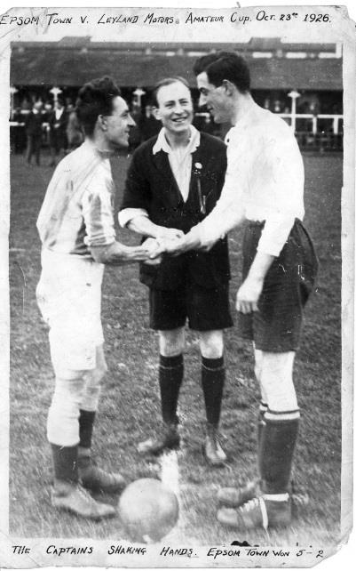
This day the visitors were Aquarius, the Southern Water Board works team that played at Honor Oak, but for this Surrey Senior Cup match the teams were drawn at West Street and Reg played one of his best games in a thumping 7-3 win. The papers described it as “a crowning conclusion to his career”, although it was Reg Marlow who scored a hat trick this day.

After the match, they held a dinner in his honour at the Spread Eagle in Epsom Town Centre where the club gave him a golf bag and gold watch, while the players gave him a cigarette case with all the players’ names on it.

Above: Reg (right) shakes hands with the Leyland Motors Captain before an Amateur Cup tie in 1926 Below: Reg scores our seventh goal in an 8-0 win over Walton at West Street in Oct 1926

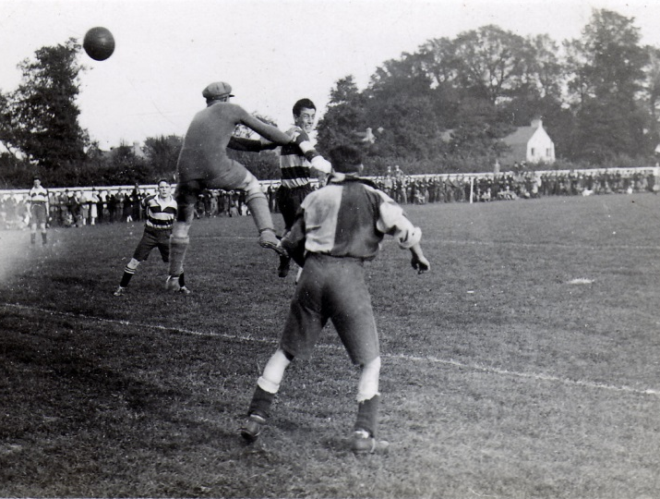
84 years ago today Billy Williams scored a hat trick in an incredible 5-5 draw with Hendon at West Street. Bizarrely a Bobby Gill penalty miss in the second half ensured that we still trailed 0-1 with just twenty minutes remaining, yet we turned it around to lead 5-2 before then conceding three times at the end! Draws like this would cost us the title as we scored twenty goals more than Champions Park Royal AND beat them twice, yet finished four points back.

28 years ago today we defeated Three Bridges in the F.A. Vase at West Street. We trailed at the break but a second half equaliser forced extra time from which we emerged with an incredible 6-2 victory! Regrettably this was the last time we won at home on this particular date!

Centre page for results

Centre page for results


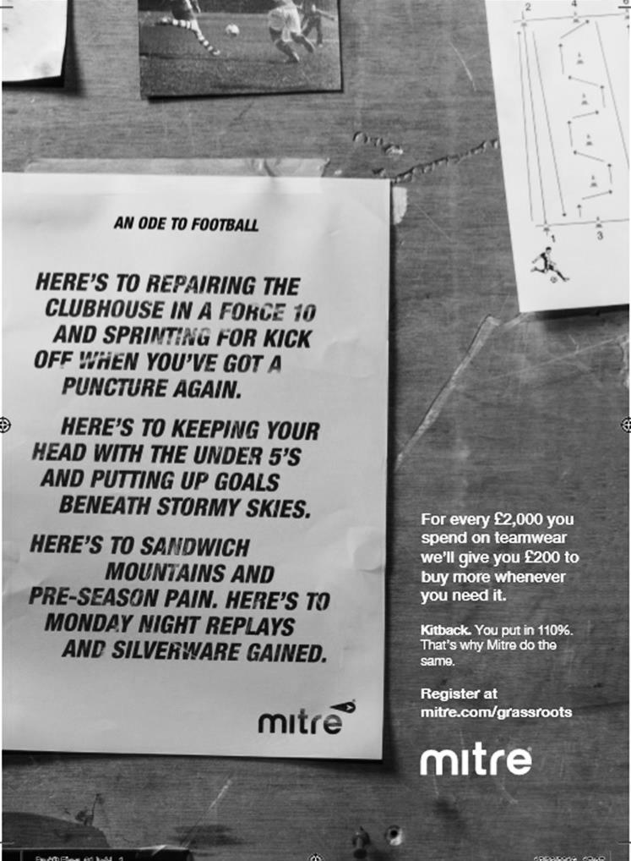

Surrey Senior Cup
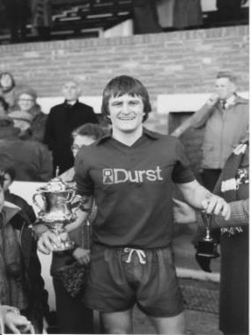
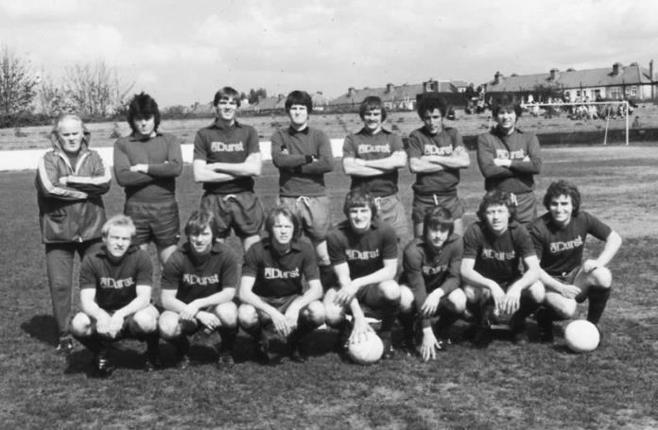
First Round
Abbey Rangers | 4-3 | AFC Croydon Athletic
Whyteleafe | 5-4 | Westfield
Second Round
Met Police | V | Kingstonian
Ashford Town (Mx) | 0-1 | Knaphill
Woking | 4-0 | Walton Casuals
Whyteleafe | 6/12 | Colliers Wood United
Guildford City | 30/11 | Horley Town
Egham Town | 3-0 | Corinthian Casuals
Godalming Town | 6/12 | Merstham
Molesey | 0-1 | Leatherhead
Raynes Park Vale | 6/12 | Sutton United
Sutton Common Rovers | 28/11 | Camberley Town
Dorking Wanderers | 6/12 | South Park
Badshot Lea | 29/11 | Farnham Town
Walton & Hersham | 3-0 | Croydon
Carshalton Athletic | 12/12 | Tooting & Mitcham United
Chertsey Town | 29/11 | Abbey Rangers
Epsom & Ewell | 6/12 | Chipstead

Buildbase F.A. Vase
Second Round – Southern Clubs only – 34 ties
Wadham Lodge | 0-3 | Ely City
Rothwell Corinthians | 1-2 | Tring Athletic
Leverstock Green | 1-2 | Welwyn Garden City
St Margaretsbury | 4-2+ | Stanway Rovers
Newport Pagnell Town | 2-1 | Broadfields United
Berkhamsted | 5-2 | Hullbridge Sports
Gorleston | 2-1 | Northampton Sileby Rangers
Cockfosters | 1-2 | Wembley
Peterborough Sports | 5-3 | Biggleswade
London Colney | 3-0 | Holmer Green
Biggleswade United | 1-1+ r 1-1+ 4-5p | Sun Sports
FC Romania | 2-0 | Ipswich Wanderers
Hoddesdon Town | 2-0 | Thetford Town
Basildon United | 3-2 | Felixstowe & Walton United
Eastbourne Town | 2-1 | Ashford United
Sutton Common Rovers | 2-1 | Sporting Club Thamesmead
Newhaven | 2-1 | Ascot United
Bedfont Sports | 2-0 | Haywards Heath Town
Eastbourne United | 0-1 | Crowborough Athletic
Walton & Hersham | 2-2+ lost 1-3p | Glebe
Camberley Town | 0-4 | Southall
Croydon | 2-1 | Andover Town
Corinthian | 3-2 | Alresford Town
Lancing | 1-7 | Horsham YMCA
Chichester City | 3-1+ | Canterbury City
Highworth Town | 1-3 | Knaphill
Epsom & Ewell | 2-3 | Abbey Rangers
Portland United | 1-2 | Blackfield & Langley
Shaftesbury Town | 1-3 | Team Solent
Brimscombe & Thrupp | 2-2+ r0-5 | Bradford Town
Bristol Manor Farm | 2-1 | Odd Down
Moneyfields | 0-4 | Thatcham Town
Cullompton Rangers | 1-1+ r2-3 | Bemerton Heath Harlequins
Hartley Wintney | 1-2 | Melksham Town
Gillingham Town | 0-1 | Exmouth Town
Buckland Athletic | 1-0 | Newport (IW)

Buildbase F.A. Vase
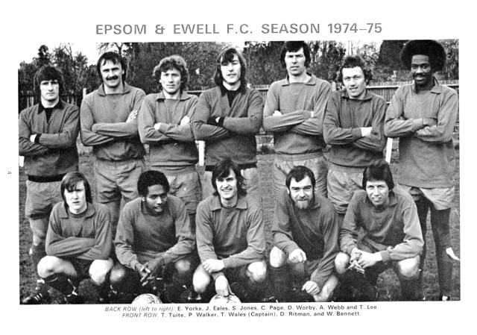

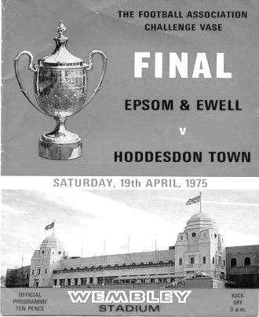
Third Round – 32 ties
North Shields | V | Shildon
Newton Aycliffe | V | Morpeth Town
Cleethorpes Town | V | Bootle
South Shields | V | Staveley MW
Penrith AFC | V | Atherton Collieries
Dunston UTS / Hemsworth Miners Welfare | V | Sunderland RCA
Bottesford Town | V | Billingham Town
Hucknall Town AFC | V | AFC Mansfield
Nuneaton Griff | V | Bromsgrove Sporting
Sporting Khalsa | V | Sleaford Town
Coleshill Town | V | Westfields
Hinckley AFC | V | Quorn
Long Eaton United | V | Shepshed Dynamo
Wembley | V | Peterborough Sports
FC Romania | V | Tring Athletic
Newport Pagnell Town | V | London Colney
Gorleston | V | Basildon United
St Margaretsbury | V | Berkhamsted
Sun Sports | V | Hoddesdon Town
Welwyn Garden City | V | Ely City
Abbey Rangers | V | Eastbourne Town
Crowborough Athletic | V | Bedfont Sports
Croydon | V | Glebe
Knaphill | V | Southall
Newhaven | V | Chichester
Sutton Common Rovers | V | Corinthian
Horsham YMCA | V | Buckland Athletic
Bemerton Heath Harlequins | V | Melksham Town
Team Solent | V | Bodmin Town
Bradford Town | V | Torpoint Athletic
Bristol Manor Farm | V | Thatcham Town
Exmouth Town | V | Blackfield & Langley
1-0
CCL Premier Division Club Directory
ABBEY RANGERS Telephone: 01932-422962 - Ground: Addlestone Moor, Addlestone, Surrey KT15 2QH - Colours: Black & White Stripes/Black/Black

A.F.C. HAYES Telephone: 0208-845-0110 - Ground: Farm Park, Kingshill Avenue, Hayes, Middx. UB4 8DD - Colours: Blue and White Stripes/Blue/Blue

BADSHOT LEA Telephone: 01252-320385 - Ground: Ash United FC, Shawfield Stadium, Youngs Drive, Shawfields Road, Ash, Hampshire. GU12 6RE - Colours: Claret/White/Claret

BEDFONT & FELTHAM Telephone: 0208 890 7264 - Ground: The Orchard, Hatton Road, Bedfont, Middx TW14 9QT - Colours: Yellow & Blue/Blue/Blue

BEDFONT SPORTS Telephone: 0208-831-9067 - Ground: Bedfont Sports Club, Hatton Road, Bedfont, Middx TW14 8JA - Colours: Red & Black Hoops/Black/Red & Black Hoops

CAMBERLEY TOWN Telephone: 01276-65392 - Ground: Krooner Park, Wilton Road, Camberley, Surrey. GU15 2QW - Colours: Red & White Stripes/Blue/Red

CB HOUNSLOW UNITED Telephone: 0208 890 7264 - Ground: The Orchard, Hatton Road, Bedfont, Middx TW14 9QT - Colours: Green/Black/Green

CHERTSEY TOWN Telephone: 01932-561774 - Ground: Alwyns Lane, Chertsey, Surrey. KT16 9DW - Colours: Royal Blue & White Stripes/Royal Blue/Royal Blue

COLLIERS WOOD UNITED Telephone: 0208-942 8062 - Ground: Wibbandune Sports Ground, Robin Hood Way, Wimbledon. SW20 0AA - Colours: Blue & Black Stripes/Black/Black
EPSOM & EWELL Telephone: 01737-553250 - Ground: Chipstead FC, High Road, Chipstead, Surrey. CR5 3SF - Colours: Royal Blue & White Hoops/Royal Blue/Royal Blue

FARNHAM TOWN Telephone: 01252-715305 Ground: Memorial Ground, Babbs Mead, West Street, Farnham, Surrey. GU9 7DY Colours: - Claret & Sky Blue /White/ Claret & Sky Blue

GUILDFORD CITY Telephone: 01483-443322 - Ground: The Spectrum, Parkway, Guildford, Surrey. GU1 1UP - Colours: Red & White Stripes/Black/Black

HANWORTH VILLA Telephone: 0208-831-9391 - Ground: Rectory Meadows, Park Road, off Hounslow Road, Hanworth, Middlesex. TW13 6PN - Colours: Red & White Stripes/Black/Black

HARTLEY WINTNEY Telephone: 01252-843586 - Ground: Memorial Playing Fields, Green Lane, Hartley Wintney, Hants RG27 8DL - Colours: Orange & Black/ Orange /Orange

HORLEY TOWN Telephone: 01293-822000 - Ground: The New Defence, Anderson Way, Court Lodge Road, Horley, Surrey. RH6 8SP - Colours: Claret & Sky Blue/Claret/Claret

KNAPHILL Telephone: 01483-475150 - Ground: Brookwood Country Park, Redding Way, Lower Guildford Road, Knaphill, Surrey. GU21 2AY - Colours: Red/Black/Red

NORTH GREENFORD UNITED Telephone: 0208 422 8923 - Ground: Berkeley Fields, Berkeley Avenue, Greenford, Middx UB6 0NX - Colours: Royal Blue & White/Royal Blue/Royal Blue

SUTTON COMMON ROVERS Telephone: 01932-866386 - Ground: Sutton United FC, Gander Green Lane, Sutton, Surrey SM1 2EY - Colours: Yellow/Black/Black

RAYNES PARK VALE Telephone: 020-8540-8843 - Ground: Prince Georges Playing Field, Grand Drive, Raynes Park, London. SW20 9NB - Colours: Blue/Blue/Red

SPELTHORNE SPORTS Telephone: 01932-961055 - Ground: Spelthorne Sports Club, Staines Road, Ashford Common, Ashford, Middx. TW15 1RY - Colours: Light & Dark Blue/Dark Blue/Light Blue

WALTON & HERSHAM Telephone: 01932 245263 - Ground: Stompond Lane, Walton on Thames, Surrey KT12 1HF - Colours: Red/Red/Red

WESTFIELD Telephone: 01483-771106 - Ground: Woking Park, Kingfield Road, Woking, Surrey. GU22 9BA - Colours: Yellow/Black/Black

WINDSOR Telephone: 01753-860656 - Ground: Stag Meadow, St Leonards Road, Windsor, Berks SL4 3DR - Colours: Red/Red/Red

Every Opponent A-Z

Over the years we have played many, many different opponents. Exactly how many is a difficult question, as it all depends on your definition. Are Camberley & Yorktown different to Camberley Town, or are Epsom Town different to Epsom F.C. or Epsom & Ewell F.C.?

In my analysis I have classed both of the above examples as the same team, and will work through them all from A to Z. Some we have played many times, whilst others we have met just once or twice. Enjoy!

Tilbury: Played 65 - W23 D13 L29 - F123 A124 - PPG - 1.26 - Average

On the list of all the clubs we have played, only three have been met more often than Tilbury. If you exclude Surrey clubs (Camberley, Carshalton Athletic and Dorking), they are at the top of the list with 65 encounters between 1932 and 2000, despite being way over in Essex.

The Dockers, as they are known, first travelled to us as new members of the London League on 6th February 1932. Clearly they were new to travelling long distances and they arrived very late at West Street that foggy day, so it was decided we would play for 30 minutes each way. Captain George Mackesy missed a penalty for us and we drew 0-0, but the League advised that in its rules a match had to be at least 40 minutes each way and forced us to replay it on 7th May when we defeated them 4-0. Just two weeks previously we made our first trip there, also losing 4-0 and this set a pattern that would remain for many years. In fact, of our 21 meetings between 1932-39 Tilbury never won at Epsom, while we only won once; a 2-0 victory on 9th January 1937!

There were only five draws in that sequence, and two of those came in 1937/38 when the teams drew 1-1 at West Street in the London League Cup on 28th August and then 3-3 in the replay after extra time on 13th November. We finally progressed in the second replay in February 1938 by the astonishing score of eight goals to one at West Street but we had held the competition up so much that the remainder of it was held over until the 1938/39 season with no new one that year. We would at least reach the Final, so it was worth waiting for!

The venue for all ten of our pre-war trips was the Orient Field. This ground was very close to the ground that many older supporters remember, and indeed where they still play, St Chad’s Road. It transpires that the owner of the site was a Leyton Orient Director but he wanted them to become a feeder club, which they were unwilling to do, so moved out and into the former Greyhound racing venue next door. Tilbury rejoined the London League in 1946/47 and we first visited Chadfields on 11th January 1947, losing by the only goal scored. We would lose the next six meetings also, three of which were at home as they finally broke their travelling duck.

In 1949 we moved to the Corinthian League but they followed us a season later and League meetings continued until 1956/57. The most notable of which was a shocking 2-7 home defeat on 20th February 1954. However, the teams got on well and we hosted a friendly for them on 6th April 1953 to raise funds as they had survived for nearly three months without a home game, following the late January 1953 storm and floods that killed 10,000 people on the Thames Estuary alone.

In 1957 Tilbury left for the London League again where they became Champions for four straight seasons until 1962 when they left for the Delphian League. However, the harsh winter of 1962/63 forced the League to be abandoned! It was due to end that season anyway as it, together with our own Corinthian League was to merge with the Athenian League into a three division structure with promotion and relegation. The Delphian clubs were placed in the new Division Two, a step below our Division, but they won the title in 1963/64 and came up to renew acquaintances. We met

three times, drawing 2-2 at home, but losing 3-0 at home in the League Cup and 8-1 at Tilbury in the return League match. We finished bottom that year to suffer the first relegation in our history.

Tilbury went from strength to strength, winning the Athenian League Division One and then coming third in the top flight for 1972/73 which earned them entry to the newly formed Isthmian League Division Two. We of course went in the opposite direction, meeting just twice in F.A. Cup ties, losing 1-0 over there in 1968/69 and then losing at home by the same score exactly 52 weeks later.

Tilbury reached the top flight of the Isthmian League in 1977, but they were relegated in 1980. We of course climbed up through the Surrey Senior and Athenian Leagues under Pat O’Connell and joined the Isthmian League in 1977. We went up in 1978 so for 1980/81 we were reunited once again in Division One. The first meeting was an F.A. Trophy disaster as we crashed at home 5-2 on 6th September 1980 but we won both League matches 2-0 and 5-0 and completed another League double the following season with a 1-0 home win and a 4-1 win at Tilbury that was delayed for a while due to a temporary floodlight failure. These two League doubles were only our third and fourth, having only recorded two in the previous 50 years, in 1936/37 and 1956/57!

In fact, in eight meetings until 1984 when we went up, we didn’t lose any, winning five of them. When we returned to Division One after our two year sojourn in the Premier Division, they were waiting for us, and we shared the results with a home win each but both were relegated at the end of the season anyway. A second win for either club would have saved them!

We went into Division Two South while they went into the North Division but in 1991 the League removed the split and Divisions Two and Three were created in their place with Tilbury joining us in Division Three, although they bounced straight back that season. Their last match at West Street being a goalless draw on 25th April 1992, as the first had been just over sixty years previously.

They dropped back down for 1998/99 when they beat us home and away, the latter being an embarrassing 0-5 Easter Monday home defeat at Merland Rise, but the following season we drew there 1-1 on 18th December 1999 and in our last meeting to date on Saturday 8th April 2000 we gained revenge for the previous year with a 6-1 home win.

We won the battle but lost the war as they were promoted in Third place and survived there until the League reorganisations in 2004 when they were moved to the Southern League, promptly finishing bottom and dropping to Step Five in the Essex Senior League. They were fortunate to be promoted back the following season, despite only finishing third and now compete back in the Isthmian League North Division, having won the Isthmian League Cup in 2009, a feat they originally achieved when the cup was first competed for in 1975.

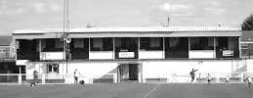
The rather unusual main stand at Chadfields

Player Sponsorship
Here is the current list for the 2016/17 season showing all of our players and Management that are available for sponsorship.

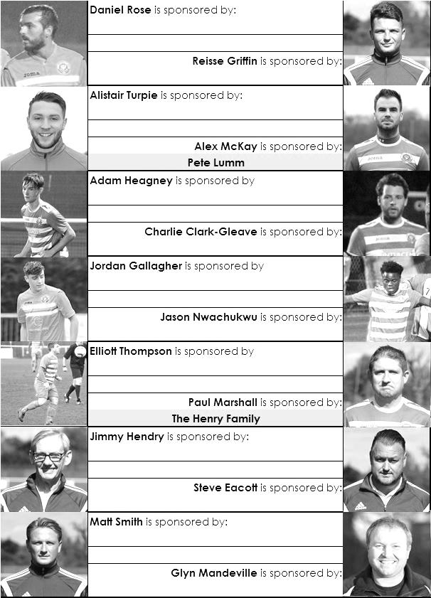

Sponsorship costs just £40 and it is easy to do. Just select a player who has not been previously sponsored and let a Committee Member know that you would like to sponsor them. Beware though. Until we have received the money it is possible for someone to jump in front of you, so don’t delay, sponsor today!
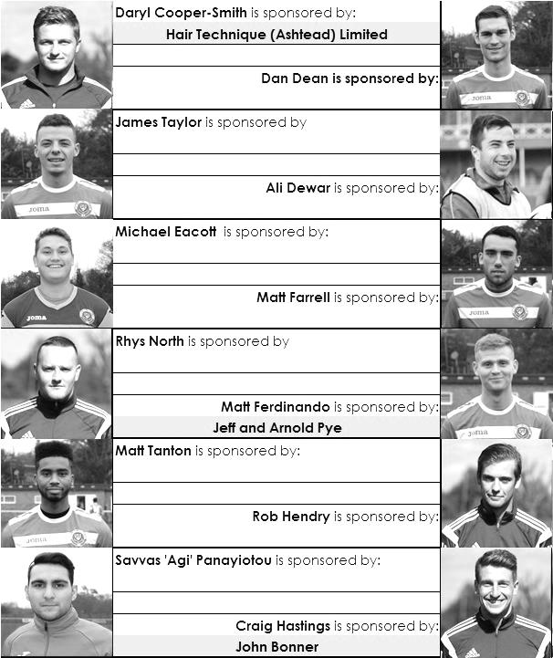

Match and Ball Sponsorships – 2016/17
Opponent | Date | Match Sponsor | Ball Sponsor
Gravesham Borough | 07/08/16 | Club President - Stella Lamont
Gravesham Borough | 07/08/16 | Relocation Committee Member - Mike Lovett
CB Hounslow United | 16/08/16 | EEFC Management Committee
Abbey Rangers | 23/08/16 | Steve & Geoff Dyke
Horley Town (11.30am) | 29/08/16 | In Memory of Chris Henry
Abbey Rangers (LC) | 06/09/16 | Paul Merritt
Camberley Town | 10/09/16 | Building Shop Ltd
Knaphill | 24/09/16 | EEFC Holding Company Director – Pete Lumm
Bridon Ropes (FAV) | 22/10/16 | George and Joseph Saunders
Sutton Common Rovers | 08/11/15 | Alex McKay Senior
Abbey Rangers (FAV) | 13/11/16 | EEFC Holding Company Director – Dave Ellins
Windsor | 15/11/16 | In Memory of Wally Dyke
Bedfont Sports | 19/11/16 | John Bonner
AFC Hayes | 26/11/16 | Jack Jarman
Chipstead (SSC) | 06/12/16
Hanworth Villa | 13/12/16
Chertsey Town | 17/12/16
Raynes Park Vale (11.30am) | 27/12/16
Spelthorne Sports | 07/01/17
Guildford City | 17/01/17
Bedfont & Feltham | 21/01/17 | Programme Editor - Richard Lambert
Badshot Lea | 04/02/17
Westfield | 18/02/17
Walton & Hersham | 04/03/17
Hartley Wintney | 18/03/17
Farnham Town | 25/03/17
Colliers Wood United (1pm) | 14/04/17 | Good Friday match – make a note!
North Greenford United | 22/04/17 | Club President - Stella Lamont
For League, League Cup and Surrey Senior Cup Matches:
Match sponsorship - £40.00 Match ball sponsorship - £25.00. Combined £55.00.
For F.A. Cup and F.A. Vase matches:
Match sponsorship - £50.00 Match ball sponsorship - £30.00. Combined £65.00.

Sponsorship includes: (x2 for match, x3 for match and ball)

Admission, programmes, hospitality and advertising and mascot for the day (if required).
If you are interested, just speak to a Committee Member, or drop me an email at: richard.c.lambert@gmail.com


We also thank our Kit Sponsors INTERCEM

Salts Super Six Predictor
The Salts Super Six Predictor is live again for today’s match and the tickets are on sale at today’s game to the left of the gate.

The jackpot has grown steadily and we can now announce that we have a new record figure of £412 today.

The competition is easy to play! To win, you simply need to predict the results of six matches correctly from the three options, fill in the form and make sure it is back with our seller before the deadline on the ticket. The latest fixtures are shown below.

If you are a club regular, you just need to place your name on the sheet, although if you aren’t, then we’ll need a contact number from you too. We will announce any winners on the website within three working days, so don’t worry, we won’t miss you!

Please note that if there is more than one winner, the prize pot would be shared between the winners. All you need to do now is have a go, as many times as you like!

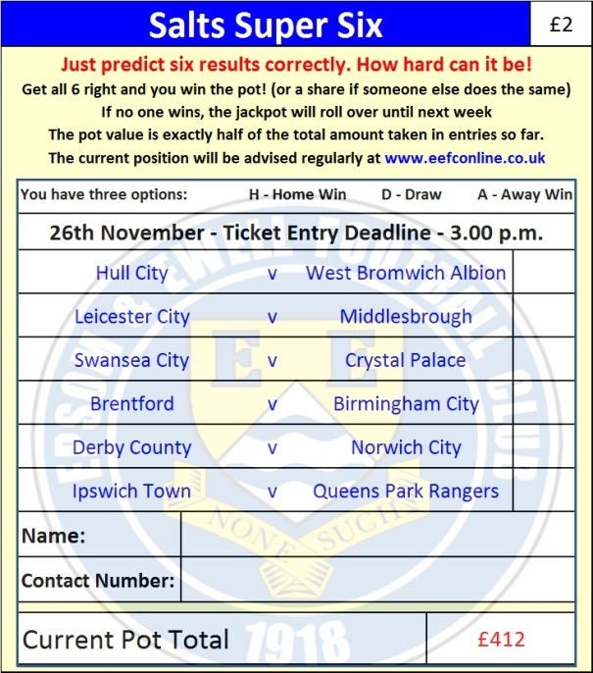

Good luck!

Combined Counties League – Premier Division
Saturday, 26th November 2016 - Kick-off 3.00 p.m.
Epsom and Ewell  (Royal Blue & White hoops) | V |  | AFC Hayes  (All Yellow)
Squad | NUMBERS
Michael Eacott |  |  | Cameron Kennedy
James Taylor |  |  | Harry Bishop
Matt Tanton |  |  | Kildane Tesfu
Craig Hastings |  |  | Ryan Egan
© Dan Dean |  |  | Reece Charles Jones
Savvas ‘Agi’ Panayiotou |  |  | Daniel McDonnel
Jordan Gallagher |  |  | Karim Aissaboiu
Matt Farrell |  |  | Harry Carter
Daryl Cooper-Smith |  |  | Austin Schofield
Jason Nwachukwu |  |  | Kenneth Bosu Acquah
Matt Ferdinando |  |  | Ethan Sennett
Alex McKay |  |  | Sekani McCalmon
Reisse Griffin |  |  | Ivan Costas Suarez
Rob Hendry |  |  | Max Hubbard
Adam Heagney |  |  | Jordan Berry
Daniel Rose |  |  | Bradley Hand
Alistair Turpie |  |  | Kelvin Gachig
Charlie Clark-Gleave |  |  | Ryan Dearden
Matt Smith |  |  | Sam Sillah
Glyn Mandeville | MANAGER |  | Sean Berry
Matt Smith | ASSISTANT |  | Alan Galloway
Steve Eacott / Alex McKay / Jimmy Hendry | COACHES / PHYSIO |  | Will Bevan
REFEREE: T.Ellsmore
ASSISTANTS: D.Olugunna, J.Crichlow
Today’s Match and Match Ball are sponsored by regular supporter Mr Jack Jarman

OUR NEXT VISITORS TO HIGH ROAD
Chipstead
Surrey Senior Cup 2 & Dave Wilson Trophy X
Tuesday 6th December 2016 – 7.45 p.m.

